Author | ______________________________ | Date | ____________
Yogeshkumar Vimalan
Business Analyst
Reviewer | ________________________________  Amit Sanandiya  Project Manager | Date | ____________
Reviewer | ________________________________  Ronex Pereira  Team Lead | Date | ____________

Reviewer | ________________________________  Rajesh Patel  Team Lead | Date | ____________
Approver | ________________________________  Beauty Dadhaniya  Quality Specialist / RP | Date | ____________

TABLE OF CONTENTS
1. Introduction 3
1.1 Purpose of the Document 3
1.2 Scope 3
1.3 Abbreviations 3
2. Overall Description 3
3. Design Specification 5
3.1 Digital Goods Receiving Checklist 5
3.1.1 Packing List Module 11
3.2 RPi Pack Creation Module 13
3.3 RPi Approval Module 15
3.3.1 Document Review and Decision 16
3.3.2 RPi Approval Checklist 18
3.3.3 Combined PDF and Email 20
3.4 Batch Checker Module 21
3.5 Product Verification Pop-up 23
3.6 Print PCL Preview and Verification 26
3.7 Goods-In Summary 28
3.8 Workflow Status, Corrections and Audit Behaviour 29
4. Additional Non-Functional Requirements 30
4.1 Audit Trail 30
4.2 Availability 30
4.3 Capacity Limits 30
4.4 Performance 31
4.5 Recoverability 31
4.6 Security Requirements 31
4.7 Error Handling 31
4.8 Usability 31
4.9 Accuracy and Validity 31

1. Introduction
PLPI Batch Record Automation digitises Goods-In receipt, document-pack creation, Responsible Person approval and Product Check Log completion within the existing PLPI application. Existing functions remain unchanged unless a design change is identified in this document.

1.1 Purpose of the Document
This document defines the system design required to implement the approved URS and FS for PLPI Batch Record Automation. It describes screen changes, workflow controls, validation gates, records and audit behaviour.

1.2 Scope
The scope covers WSC India PO initiation and supplier-file upload, the tablet Goods Receiving Checklist and Goods-In Team Lead approval, Packing List Verify & Print and LOG, the RPi Pack Creation and RPi Approval modules, automatic single-PO and merged-PO document handling, combined PDF and email processing, Batch Checker evidence, Product Verification, PCL preview/printing and the read-only Goods-In Summary. Existing PLPI fields remain unchanged unless specifically identified.
Out of Scope: - Downstream BAR and production activities are outside Phase 1.

1.3 Abbreviations
PLPI means Product Label and Pack Information system. URS means User Requirement Specification. FS means Functional Specification. DS means Design Specification. PO means Purchase Order. GRC means Goods Receiving Checklist. RP / RPi means Responsible Person / Responsible Person Import. PCL means Product Check Log.
WDA means Wholesale Distribution Authorisation. FMD means Falsified Medicines Directive. QA means Quality Assurance and IT means Information Technology.

2. Overall Description
The design extends the existing PLPI application with controlled queues, automatic document linkage and approval gates. WSC India initiates the PO in Add Packing List and uploads the three supplier source files; saving that entry creates the RPi Pack Creation queue immediately. Separately, the WSC user selects Generate Checklist in the Warehouse Stock Control Booked Orders screen, which creates the receipt work item in the Goods-In Team tablet queue.
Goods-In completes the tablet delivery and inspection record and submits it to the separate Lead Approval queue. The Goods-In Team Lead reviews the submitted data read-only and records the Information Confirmed decision, comments, signature and final confirmation. A Yes decision completes, locks and files the checklist PDF; a No decision quarantines the stock and routes the receipt to QA investigation. QA approval is not mandatory for a normal accepted receipt.
After Team Lead approval, Goods-In completes Verify & Print, reviews the LOG, completes line clearance and generates the PO Packing List. The RPi Pack Creation workspace is progressively populated: Add Packing List files, the completed checklist and each generated Packing List are attached automatically. When one checklist contains multiple POs, PLPI creates one merged PO set automatically, stores shared documents once and retains PO-specific documents against each PO.
The Responsible Person reviews shared documents once and PO-specific documents, including each generated Packing List, against the applicable PO. Approval produces the combined PDF and email record. After external stock-control acceptance is reflected in PLPI, Batch Checker verification and PCL printing complete the Phase 1 workflow. Authorised users may review status and history through the read-only Goods-In Summary.
Workflow control: Each action is enabled only when the mandatory data, signatures, documents and preceding approvals are complete. PLPI retains the applicable PO or merged set, previous and new status, authenticated user, role, date/time and comments at each controlled event.
End-to-end design sequence: The following visual shows the normal ownership hand-offs, automatic document population, validation gates and controlled outputs.
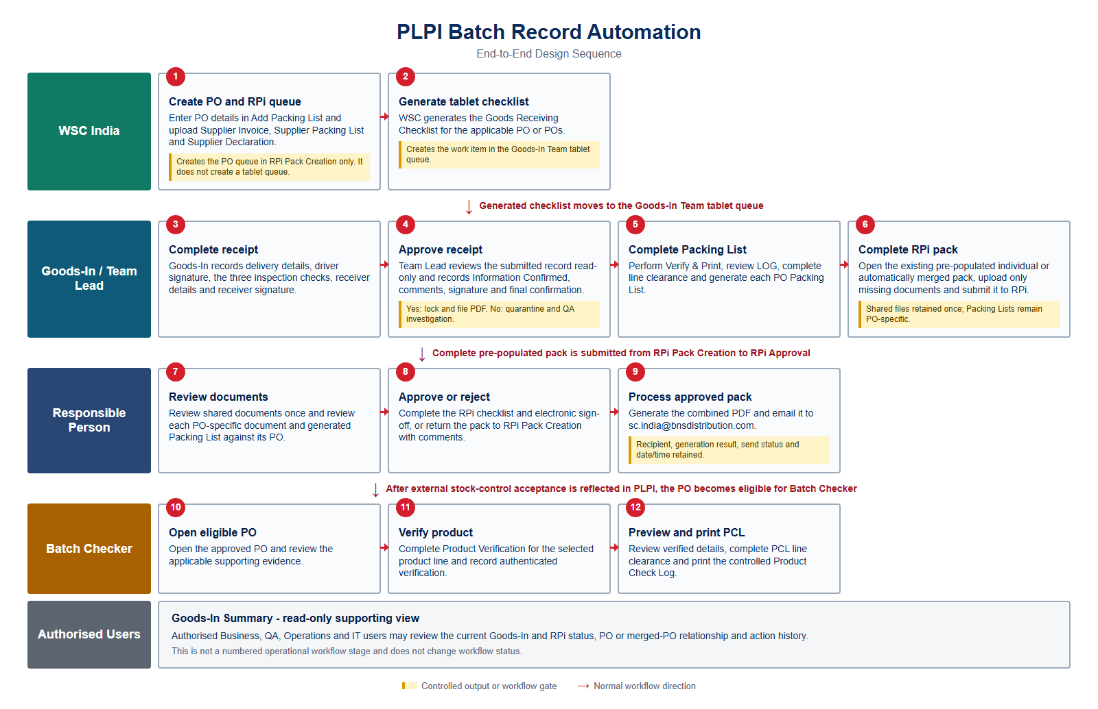
Figure 1 - End-to-end PLPI Batch Record Automation design sequence
Queue separation: Saving Add Packing List creates the PO queue in RPi Pack Creation only. Generating the Goods Receiving Checklist creates the work item in the Goods-In Team tablet queue. The normal workflow then continues through Goods-In and Team Lead approval, Packing List completion, RPi approval, PDF/email processing, Batch Checker verification and PCL completion. Goods-In Summary remains a separate read-only supporting view.

3. Design Specification
The following sections define the screen and workflow design that will be implemented to satisfy the current URS and FS.

3.1 Digital Goods Receiving Checklist
Add Packing List and WSC Warehouse Stock Control perform separate initiation functions. Saving the Add Packing List entry creates the PO queue in RPi Pack Creation and links the Supplier Invoice, Supplier Packing List and Supplier Declaration. The tablet workflow starts only when the WSC user selects Generate Checklist for the booked PO or POs in Warehouse Stock Control; this creates the receipt in the Goods-In Team tablet queue. Lead Approval remains a separate role-controlled queue.
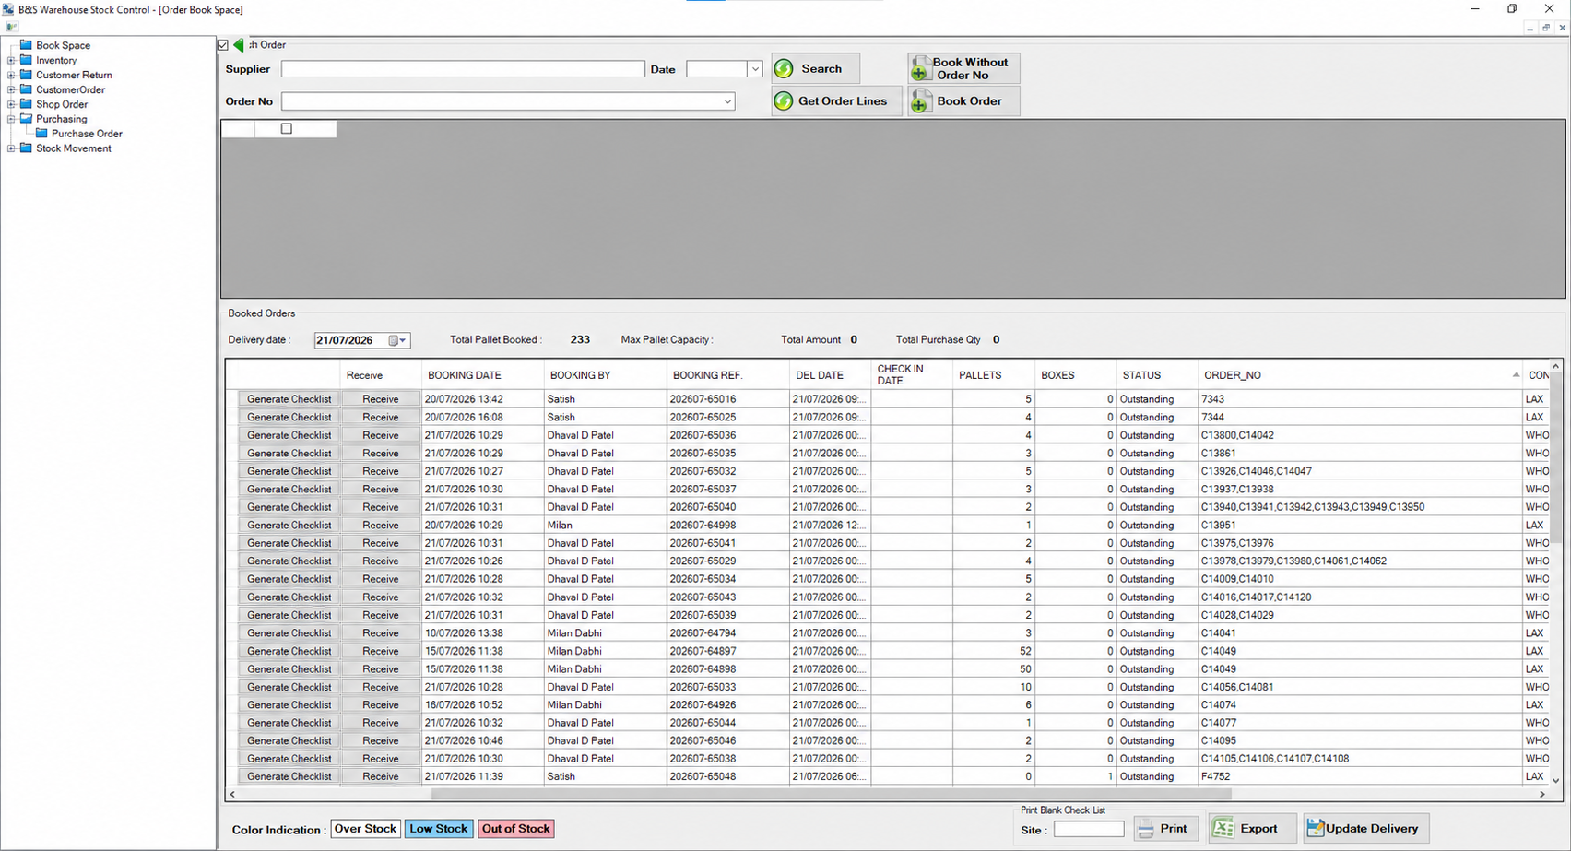
Figure 2 - WSC Warehouse Stock Control Generate Checklist action
Screen logic - Booked Orders. Warehouse Stock Control displays the booked delivery records and associated PO number or PO numbers available for checklist generation.
Generate Checklist - Selecting this action generates the Goods Receiving Checklist for the selected booked record and creates the corresponding work item in the Goods-In Team tablet queue.
Queue separation - Generate Checklist does not create the RPi Pack Creation queue. That queue is created separately when the Add Packing List entry is saved.
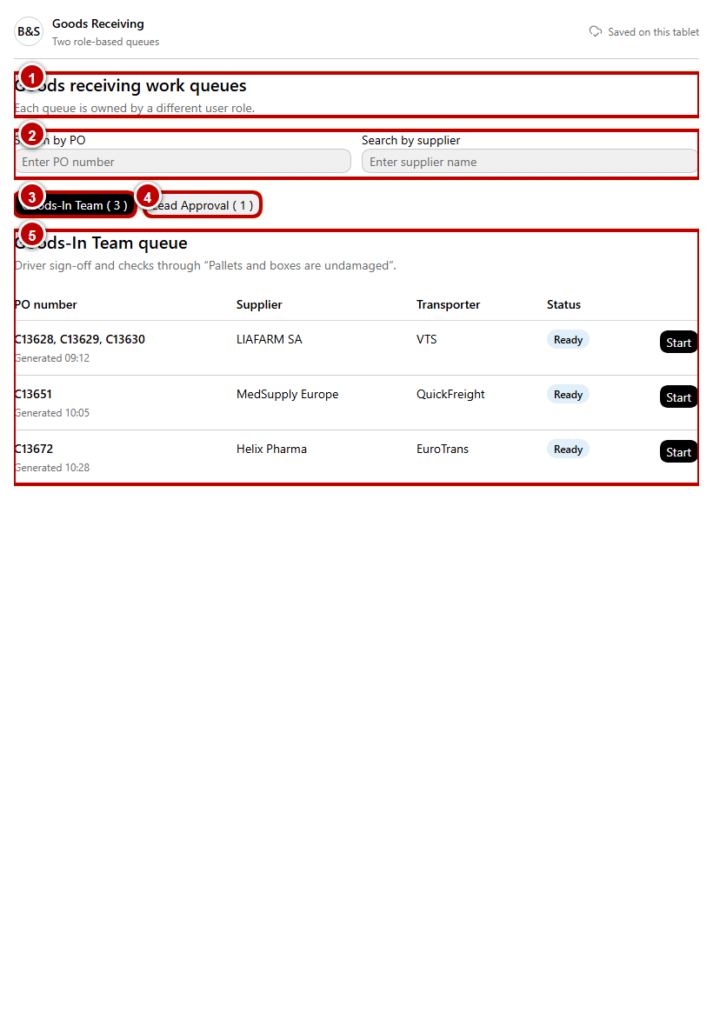
Figure 3 - Tablet role queues and WSC-generated Goods-In work item
Callout 1 - Role queues. The Goods-In Team and Lead Approval tabs separate data capture from approval. A user sees only queues permitted for the authenticated role.
Callout 2 - Goods-In Team queue. Each generated checklist displays the linked PO reference or PO references, supplier, generated date/time and current status. Search and status filters locate the applicable receipt without creating a new checklist.
Callout 3 - Lead Approval queue. A record appears here only after Goods-In selects Send for Goods-In Approval. The submitted Goods-In data remains read-only to the Team Lead.
Callout 4 - Queue status and continuation. Draft records remain available to the owning queue. Submitted records cannot be amended by Goods-In unless returned through the controlled correction process.
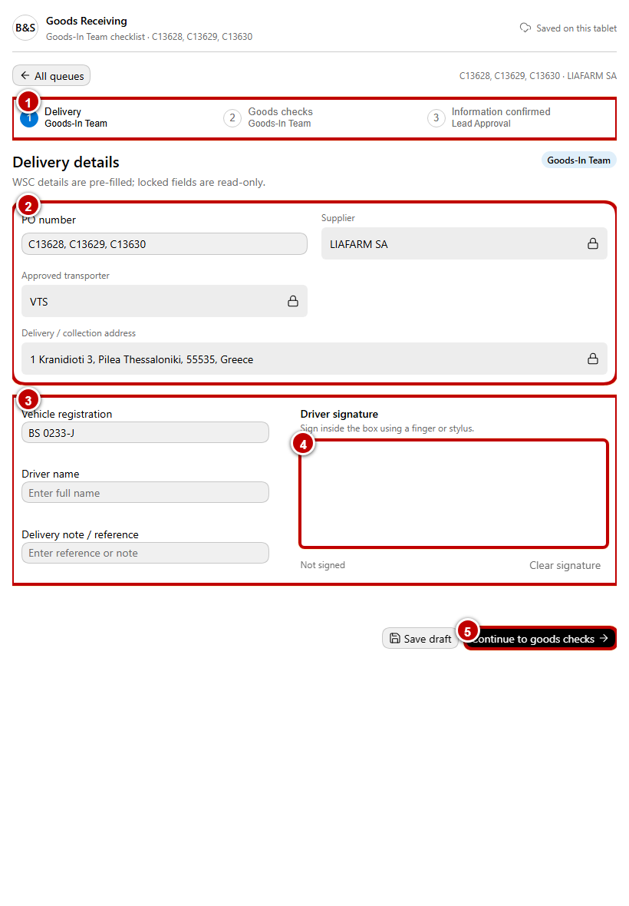
Figure 4 - Goods-In delivery details and driver signature
Callout 1 - WSC context. PO Number, Supplier and other WSC-generated receipt context are displayed from the source record and remain linked to the checklist.
Callout 2 - Delivery details. Goods-In records the applicable vehicle, driver and delivery-reference information. Mandatory values are validated before the inspection stage opens.
Callout 3 - Driver signature. The signature is captured on the approved tablet and retained with the checklist record. Clear permits recapture before submission.
Callout 4 - Draft and progression controls. Save Draft retains an unfinished Goods-In record. Continue is enabled only when the required delivery information and driver signature are present.
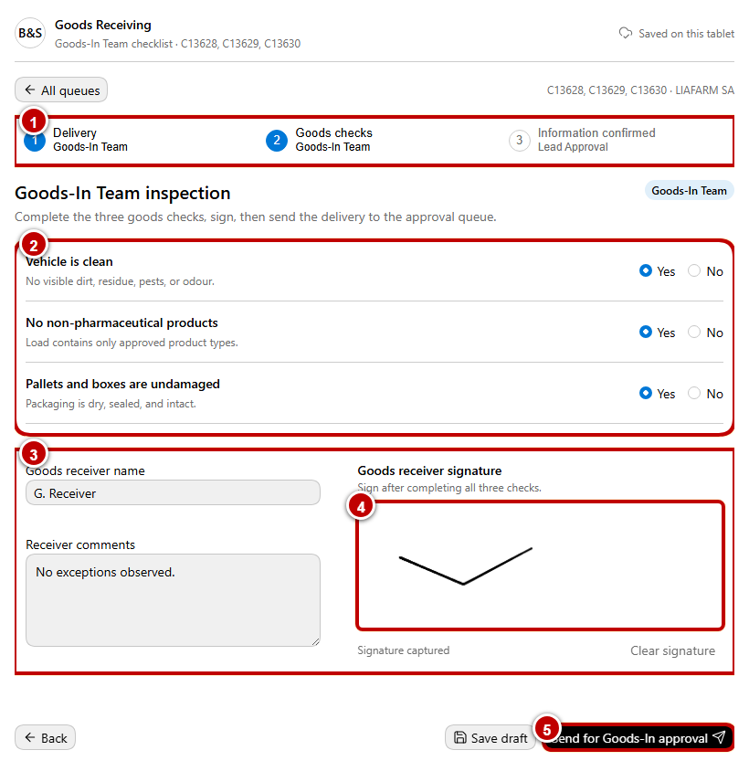
Figure 5 - Goods-In inspection, receiver sign-off and approval submission
Callout 1 - Goods-In inspection. The user records the three required checks: vehicle clean, no non-pharmaceutical products, and pallets or boxes undamaged. Each check requires a controlled Yes or No response.
Callout 2 - Receiver details. Goods Receiver name and the receiver signature are mandatory. Comments provide context for damage, exceptions or other receipt information.
Callout 3 - Send for Goods-In Approval. The action validates the delivery information, three checks and both signatures, then transfers the record to the Lead Approval queue. It does not complete or file the controlled PDF.
Callout 4 - Audit hand-off. PLPI records the submitting Goods-In user, role, date/time and status change while retaining the submitted data as the approval baseline.
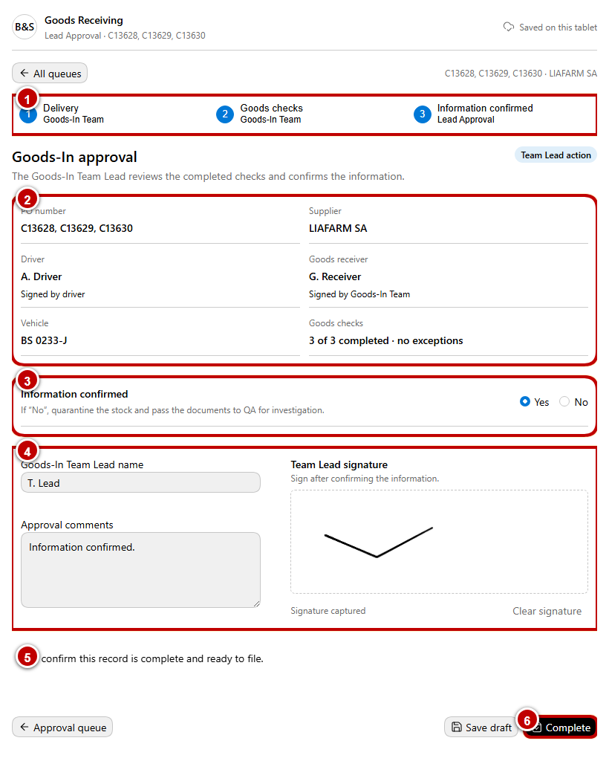
Figure 6 - Goods-In Team Lead approval and completion gate
Callout 1 - Read-only submitted record. Delivery details, inspection responses, receiver information and signatures are displayed to the Team Lead without amendment controls.
Callout 2 - Information Confirmed. The Team Lead records Yes or No. Yes, permits normal completion; No records the exception, quarantines the stock and routes the receipt to QA investigation.
Callout 3 - Team Lead attribution. Team Lead name, approval comments and Team Lead signature are captured. Save Draft retains an incomplete approval without changing the submitted record.
Callout 4 - Final confirmation and Complete. Complete remains disabled until the Team Lead decision, mandatory identity/signature information and final record confirmation are present. Successful completion creates the Team Lead-approved, locked and filed checklist PDF.
Detailed design sequence:
Step 1 - WSC India saves the PO in Add Packing List and uploads Supplier Invoice, Supplier Packing List and Supplier Declaration. PLPI creates the corresponding RPi Pack Creation queue and links those files immediately.
Step 2 - In WSC Warehouse Stock Control, the WSC user selects Generate Checklist for the applicable booked PO or POs. The integration creates the tablet work item and assigns it to the Goods-In Team queue against those PO references.
Step 3 - Goods-In opens the generated work item and reviews the read-only WSC context before entering delivery-specific values.
Step 4 - Goods-In records delivery details and captures the driver signature. The inspection stage remains unavailable until the required delivery gate is satisfied.
Step 5 - Goods-In completes the three controlled inspection checks, records receiver details and captures the Goods Receiver signature.
Step 6 - Goods-In may save a draft or select Send for Goods-In Approval. Submission validates mandatory data and moves the record to the Lead Approval queue.
Step 7 - The Goods-In Team Lead opens the submitted record and reviews all Goods-In data and signatures in read-only mode.
Step 8 - The Team Lead records Information Confirmed, name, approval comments and signature, then applies the final record confirmation.
Step 9 - Complete creates the final controlled PDF. A Yes decision locks and files the receipt for normal processing. A No decision records quarantine and routes the receipt to QA investigation; QA approval is not required for a normal accepted receipt.
Step 10 - For a single-PO receipt, PLPI attaches the completed checklist automatically to that PO in RPi Pack Creation. For a checklist containing multiple POs, PLPI creates one merged PO set automatically and attaches the checklist once as a shared document.
Step 11 - Goods-In continues to Packing List Verify & Print, LOG review, line clearance and PO Packing List generation. Each generated Packing List is attached automatically to its respective PO.
Draft and correction control: Goods-In and Team Lead drafts are retained separately. A submitted or completed record is changed only through the controlled return or correction process, with the previous state retained in the audit trail.
Entry condition: WSC India has saved the Add Packing List entry and the WSC user has selected Generate Checklist for the applicable booked PO or POs. Exit condition: Team Lead approval is complete, the checklist PDF is locked and linked to the applicable individual or merged PO record, or a No decision has placed the stock in quarantine and routed the receipt to QA.
URS traceability: URS 4.1.1 - 4.1.4, 4.1.10 and 4.1.12. FS traceability: FS 3.1.

3.1.1 Packing List Module
Add Packing List is used by WSC India to create and save the PO record, upload the Supplier Declaration, Supplier Packing List and Supplier Invoice, and create the PO queue in RPi Pack Creation. View Packing List is used by Goods-In to complete line verification, review LOG, complete line clearance and generate the controlled PO Packing List.
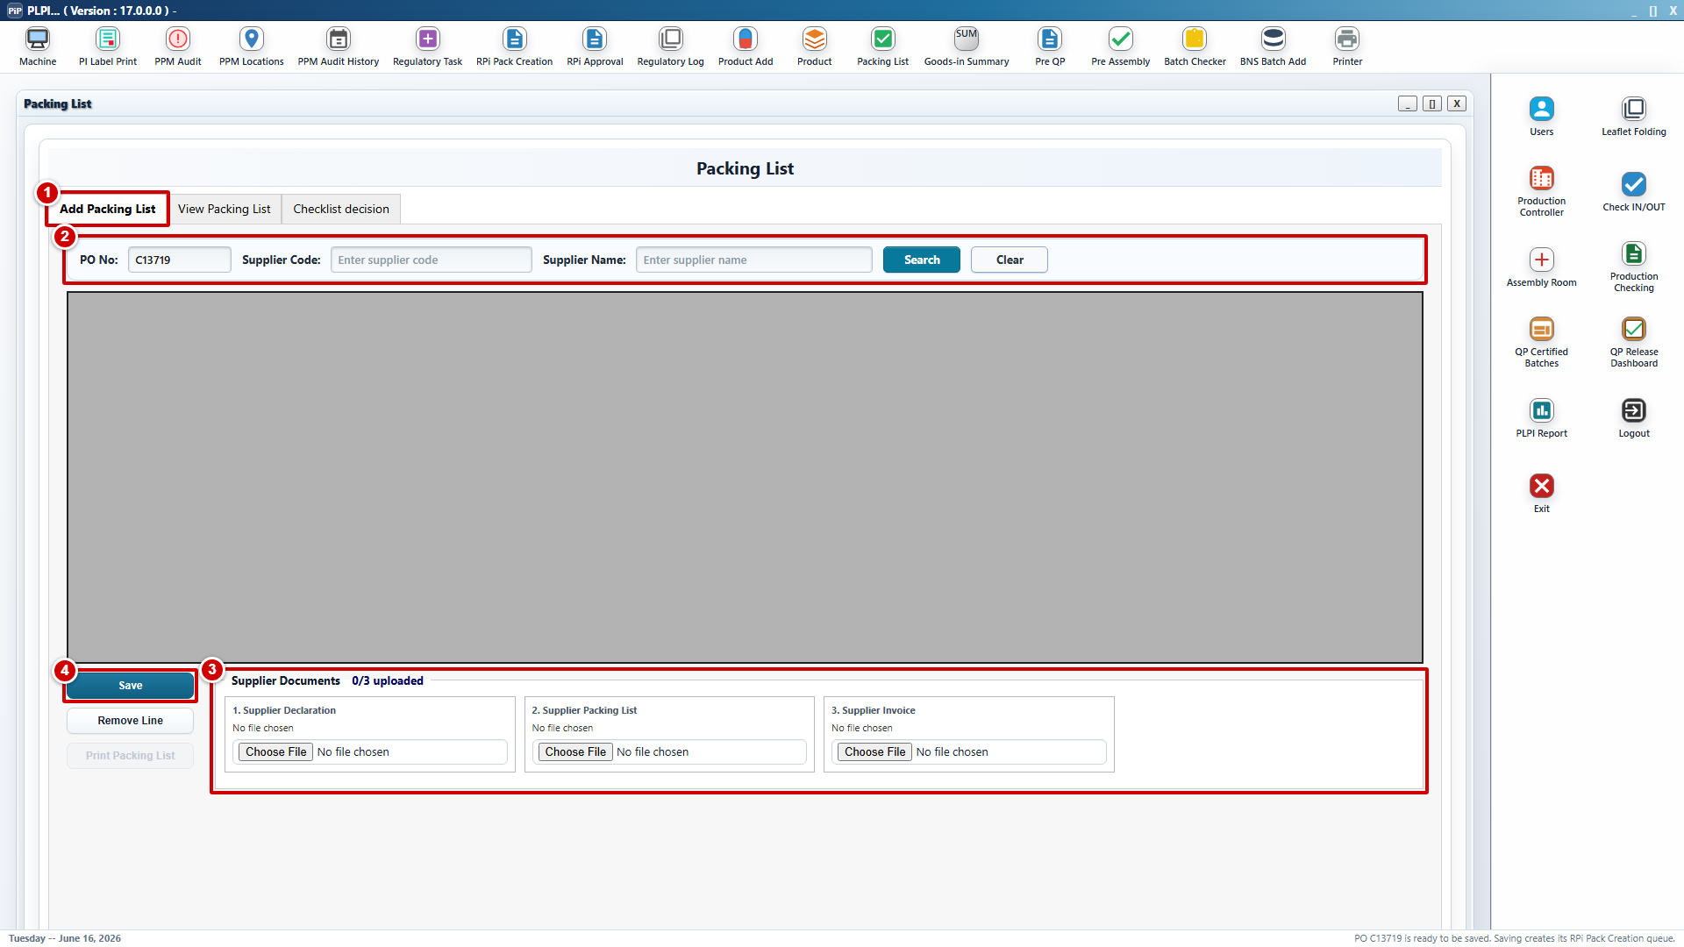
Figure 7 - Add Packing List PO entry and supplier-document uploads
Callout 1 - Add Packing List tab. WSC India uses this tab to enter and maintain the PO and supplier record before Goods-In processing.
Callout 2 - PO and supplier search. The user enters the PO number and supplier details and retrieves the applicable source information before saving the record.
Callout 3 - Supplier document uploads. The Supplier Declaration, Supplier Packing List and Supplier Invoice are uploaded against the PO. The files remain visible against that PO in RPi Pack Creation without re-upload.
Callout 4 - Save. Saving the Add Packing List entry creates the PO queue in RPi Pack Creation and records the uploaded supplier files against the PO.
Queue control: Add Packing List does not create the Goods-In tablet queue. The tablet queue is created separately when WSC selects Generate Checklist for the booked PO or POs in Warehouse Stock Control.
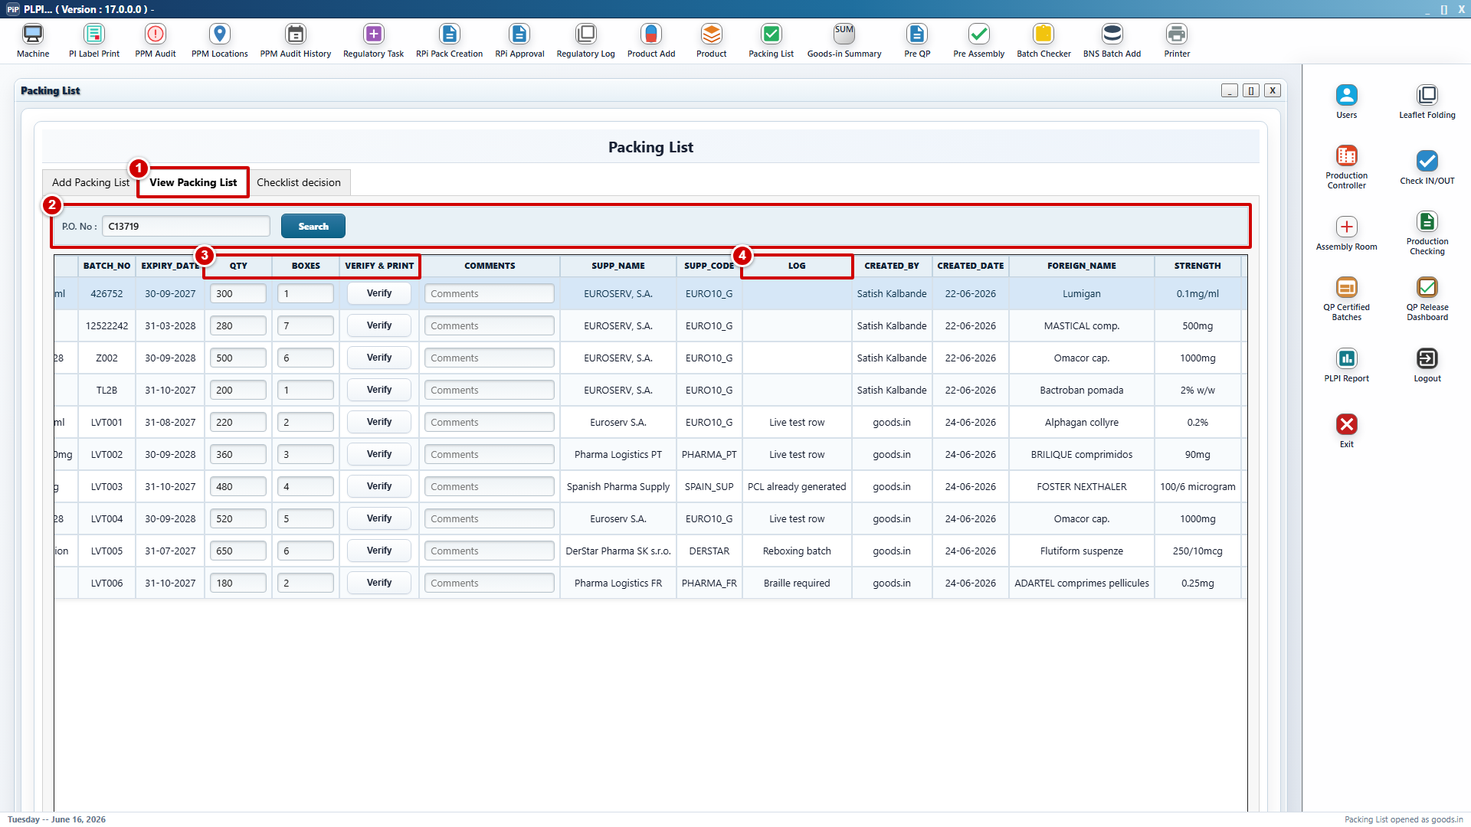
Figure 8 - View Packing List verification, LOG and generation controls
Callout 1 - View Packing List Tab. Goods-In uses this tab for Packing List line processing. RPi Pack Creation and RPi document controls are not part of this screen.
Callout 2 - PO search and line context. Goods-In opens the applicable PO after the Team Lead-approved Goods Receiving Checklist is available and reviews the existing Packing List product lines.
Callout 3 - QTY, BOXES and Verify & Print. QTY and BOXES remain existing fields. Verify & Print is the new line-level action used to complete the required confirmation, line-clearance check and authenticated sign-off for the selected line.
Callout 4 - LOG. This new read-only action displays the retained verification status, print status, authenticated user, date/time and comments for the selected line.
Generation control: Generate PO Packing List remains in the View Packing List action area and is enabled only after all applicable lines are verified, required label printing is successful and line clearance is complete. The generated Packing List is locked and attached automatically to the respective PO in RPi Pack Creation.
Detailed screen sequence:
Step 1 - WSC India enters the PO and supplier details in Add Packing List and uploads the Supplier Declaration, Supplier Packing List and Supplier Invoice.
Step 2 - Saving the Add Packing List entry creates the PO queue in RPi Pack Creation and links the three supplier files to that PO.
Step 3 - After the Goods Receiving Checklist has completed the required Team Lead or QA outcome, Goods-In searches for and opens the PO in View Packing List.
Step 4 - Goods-In selects an applicable line and chooses Verify & Print. PLPI binds the action to that line and displays the required confirmation data.
Step 5 - Goods-In completes the line-clearance confirmation and authenticated sign-off. After successful printing, PLPI records the print result, user and date/time and changes the line to Verified. A cancelled or failed action leaves the line incomplete.
Step 6 - Goods-In opens LOG to review the retained verification and printing history and resolves any identified exception through the controlled process.
Step 7 - PLPI evaluates every applicable PO line. Generate PO Packing List remains unavailable while a line is unverified, required printing is incomplete or line clearance is missing.
Step 8 - PLPI generates and locks the PO Packing List, then links it automatically to the corresponding PO-specific document group in RPi Pack Creation.
Validation and control: A locked or generated Packing List cannot be changed through Verify & Print. A controlled correction invalidates affected downstream approval or generated output and requires the applicable workflow steps to be repeated.
Entry condition: The Add Packing List entry and RPi Pack Creation queue exist, and the PO Goods Receiving Checklist has completed the required Team Lead or QA outcome. Exit condition: All applicable lines are verified and printed, line clearance is complete, and the generated Packing List is attached to the respective RPi pack.
URS traceability: URS 4.1.4 - 4.1.12. FS traceability: FS 3.1.

3.2 RPi Pack Creation Module
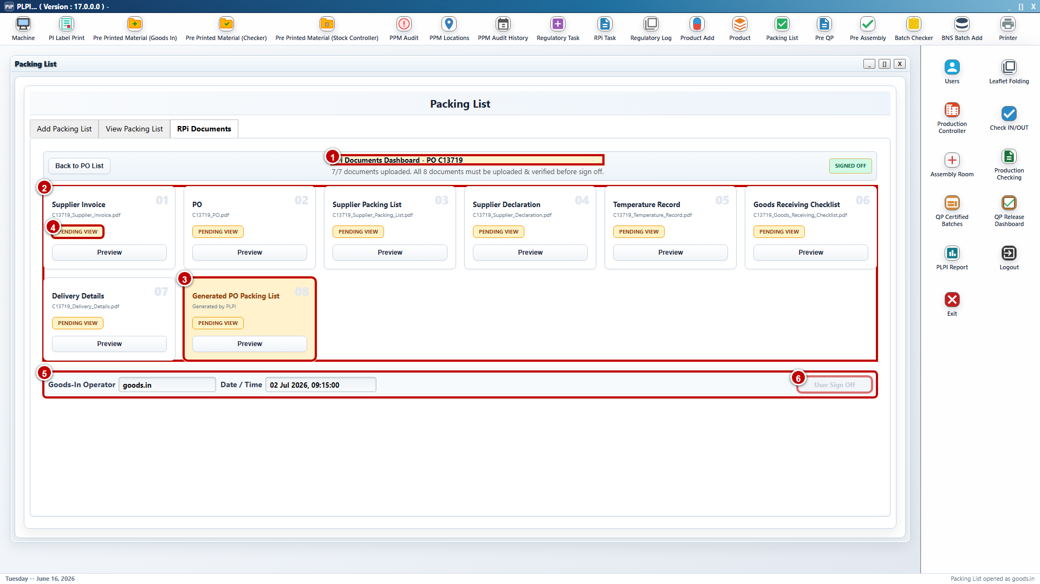
Figure 9 - RPi Pack Creation dashboard, progressive document population and Goods-In submission
RPi Pack Creation is a separate Goods-In-operated module. The PO queue is created immediately when WSC India saves the Add Packing List entry; it does not wait for Goods-In completion. The workspace is progressively populated by source uploads and controlled workflow outputs.
Callout 1 - Search and active PO queue. Search filters by PO number. The queue displays the PO or merged PO set and progressive status such as Awaiting Checklist, Checklist Complete, Packing List Pending, Documents Pending, Ready to Send, Rejected or Corrected / Re-submitted.
Callout 2 - Automatic source-file linkage. Supplier Invoice, Supplier Packing List and Supplier Declaration uploaded in Add Packing List appear against the same PO with Automatically attached or Uploaded status. Existing files are not requested again.
Callout 3 - Automatic checklist relationship. A completed single-PO checklist attaches to that PO. When one completed checklist contains multiple PO references, PLPI creates one merged PO set automatically and stores the checklist once as a shared document. No manual merge selection is required.
Callout 4 - Shared documents. Supplier Declaration, Temperature Record, Goods Receiving Checklist, CMR and Import / Export are retained once for the merged set where applicable. Their review and status apply to the merged relationship without duplicating the file against each PO.
Callout 5 - PO-specific documents. Supplier Invoice, Supplier Packing List, Additional Files and each generated PO Packing List remain associated with their respective PO. Each Packing List is attached automatically after system generation.
Callout 6 - Missing-document completion. Each tile shows Automatically attached, Uploaded or Upload required. Goods-In uploads only missing applicable documents and uses View File to confirm that each document is readable and correctly associated.
Callout 7 - Controlled unmerge. When a correction requires removal of a PO from an automatically merged set, the user selects the PO and enters a mandatory reason. PLPI retains the remaining valid group and records the unmerge event.
Callout 8 - Send PO Set to RPi. Submission is enabled only when every required shared and PO-specific document is available and the applicable Goods-In, Team Lead/QA and Packing List controls are complete. PLPI records Goods-In operator and date/time.
Detailed design sequence:
Step 1 - Add Packing List save creates the PO queue and PO/supplier context in RPi Pack Creation. The queue initially shows the checklist and Packing List as pending.
Step 2 - The three files uploaded in Add Packing List are linked to the PO and displayed without re-upload. File identity, upload source and status remain traceable.
Step 3 - Completion of a single-PO Goods Receiving Checklist links the locked PDF to that PO. Completion of a multi-PO checklist creates the merged PO set and stores the checklist once in Shared Documents.
Step 4 - Generated Packing Lists attach to the applicable PO-specific groups. A merged set therefore retains a separate controlled Packing List for each PO.
Step 5 - PLPI evaluates the shared-document and PO-specific-document requirements. The same shared file is not duplicated, while PO-specific completeness is evaluated independently for each PO.
Step 6 - Goods-In opens each automatically linked file, uploads only documents with Upload required status and resolves incorrect or unreadable files through the controlled replacement process.
Step 7 - If a PO must be removed from the merged set, Goods-In selects that PO, enters the mandatory reason and invokes Unmerge Selected PO. The audit trail records user, reason, date/time and resulting PO relationships.
Step 8 - When the pack is complete, Goods-In selects Send PO Set to RPi. PLPI validates all shared and PO-specific requirements, records the authenticated submission and changes the pack to Ready for RPi Review.
Validation and error handling: Duplicate PO association, unavailable linked files, missing mandatory documents, incomplete generated Packing Lists or an unmerge without a reason prevent submission and identify the affected PO or shared-document group.
Entry condition: Add Packing List has created the PO queue. Exit condition: A complete individual or automatically merged, pre-populated pack is submitted to RPi Approval, or a rejected pack remains available for controlled correction and re-submission.
URS traceability: URS 4.1.8, 4.1.12, 4.2.1 - 4.2.3 and 4.2.6. FS traceability: FS 3.2.

3.3 RPi Approval Module
RPi Approval is a new module. It receives complete individual or automatically merged packs from RPi Pack Creation and controls document review, approval or rejection, checklist completion, electronic sign-off, combined PDF generation and email transmission.
For a merged pack, shared documents are reviewed once for the merged set. PO-specific documents and each generated Packing List are reviewed against the respective PO before approval or rejection becomes available.
URS traceability: URS 4.2.4 - 4.2.8 and 4.2.10. FS traceability: FS 3.3.

3.3.1 Document Review and Decision
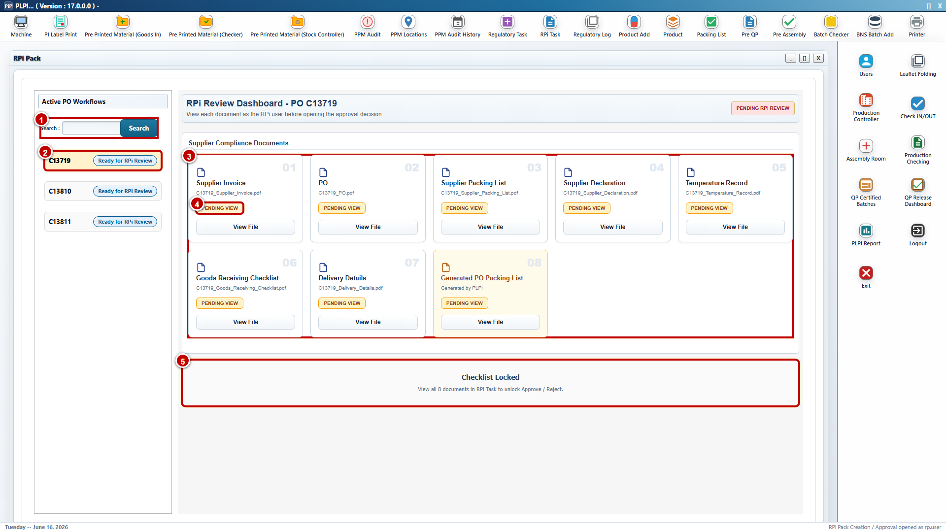
Figure 10 - RPi Approval document review workspace
Callout 1 - Queue search and pack identity. Search filters the active queue by PO, supplier, batch or status. A merged card displays all included PO numbers and preserves each PO identity throughout review.
Callout 2 - Pack readiness. Only a complete pack submitted from RPi Pack Creation opens for controlled review. Rejected or corrected packs retain the previous reason and current submission status.
Callout 3 - Shared-document group. Supplier Declaration, Temperature Record, Goods Receiving Checklist, CMR and Import / Export are displayed once for the merged set where applicable. A single recorded view satisfies the shared-file review gate.
Callout 4 - PO-specific groups. Supplier Invoice, Supplier Packing List, Additional Files and the generated Packing List are displayed under the applicable PO. Each required file must be opened for each PO.
Callout 5 - View status. View File records that the authenticated RPi user opened the applicable file. Missing, unreadable or unviewed mandatory documents keep the checklist locked.
Callout 6 - Approve or reject. Approve opens the RPi checklist only after all required views are complete. Reject requires comments and returns the pack to RPi Pack Creation with the affected pack relationship retained.
Detailed review sequence:
Step 1 - The Responsible Person locates the individual or merged pack in the active queue and confirms the displayed PO and supplier context.
Step 2 - PLPI loads Shared Documents once for the merged set and PO-Specific Documents under each included PO. Generated Packing Lists are never treated as shared.
Step 3 - The user opens every applicable shared file. PLPI records viewed status against the merged review task.
Step 4 - The user opens every required PO-specific file and generated Packing List against each PO. PLPI records the PO reference with each view event.
Step 5 - If a file is missing, incorrect or unreadable, the user selects Reject and records correction comments. PLPI returns the pack to RPi Pack Creation without discarding prior audit history.
Step 6 - A corrected pack is re-submitted and all affected document review gates are repeated. Unaffected retained files remain traceable but approval is based on the current submitted version.
Step 7 - When all required files are viewed, Approve enables the RPi Approval Checklist. PLPI records the authenticated review decision, role and date/time.
Entry condition: The pack has Ready for RPi Review status. Exit condition: The pack is returned with traceable comments or released to the RPi Approval Checklist.
URS traceability: URS 4.2.4 - 4.2.6. FS traceability: FS 3.3.

3.3.2 RPi Approval Checklist
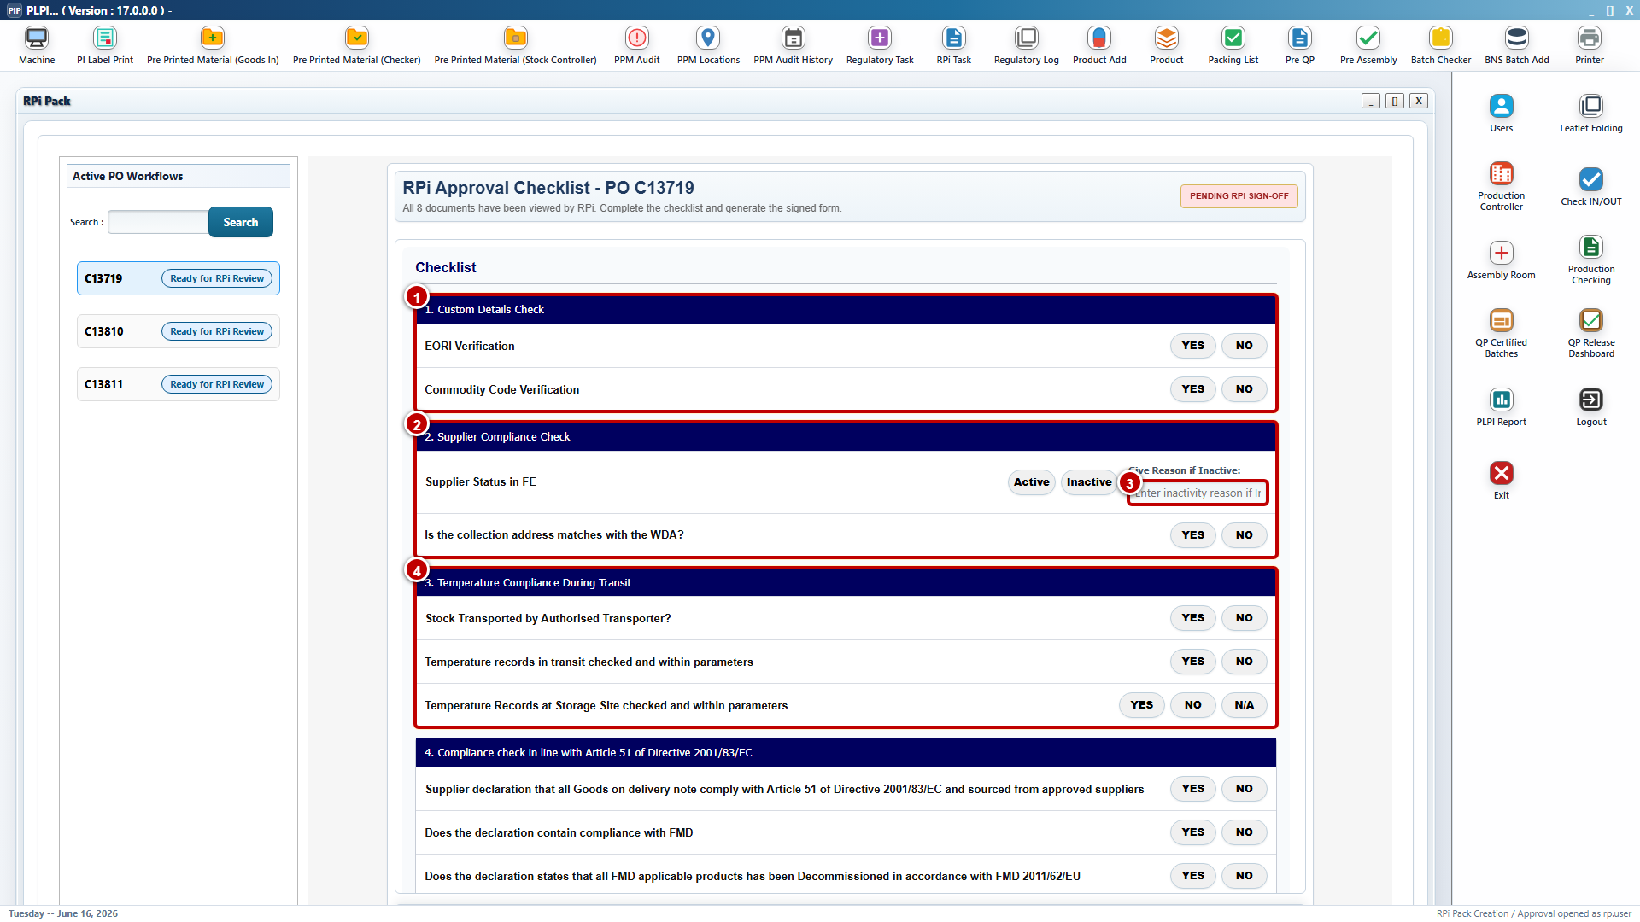
Figure 11 - RPi checklist: identity, supplier, transport and temperature controls
Callout 1 - EORI and commodity verification. The Responsible Person records the EORI Verification and Commodity Code Verification outcome against the reviewed pack.
Callout 2 - Supplier status and conditional reason. Supplier Status in FE is Active or Inactive. Reason if Inactive becomes mandatory when Inactive is selected.
Callout 3 - Distribution controls. Collection Address Matches WDA and Authorised Transporter use controlled Yes or No responses.
Callout 4 - Temperature controls. Transit Temperature Within Parameters and Storage-site Temperature Within Parameters use the applicable Yes, No or N/A options.
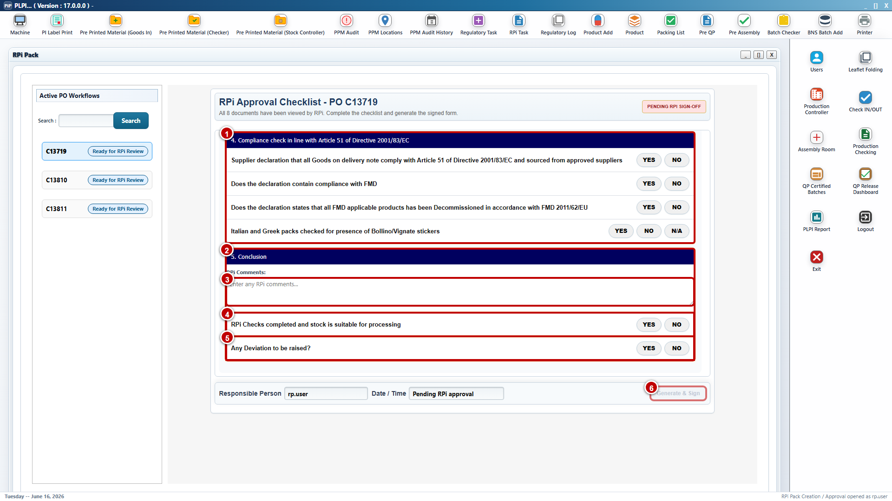
Figure 12 - RPi checklist: regulatory review, conclusion and electronic sign-off
Callout 1 - Regulatory checks. Article 51 Supplier Declaration, FMD Compliance in Declaration, FMD Decommissioning Statement and Bollino / Vignette Sticker Check are completed using the applicable controlled responses.
Callout 2 - Conclusion. RPi Comments records decision context. Stock Suitable for Processing and Deviation Required record the final disposition and any controlled follow-up.
Callout 3 - Responsible Person attribution. Responsible Person and Date/Time are populated from the authenticated session and cannot be replaced with uncontrolled free text.
Callout 4 - Generate & Sign. The action remains disabled until every mandatory document view, checklist response and conditional value is complete. Successful execution creates the signed approval record and locks the approved pack.
Detailed checklist sequence:
Step 1 - Verify EORI, commodity code and Supplier Status in FE. PLPI requires Reason if Inactive when applicable.
Step 2 - Complete Collection Address Matches WDA, Authorised Transporter and the applicable transit and storage-site temperature controls.
Step 3 - Complete Article 51, FMD compliance, FMD decommissioning and Bollino / Vignette checks using N/A only where the configured rule permits it.
Step 4 - Record RPi Comments, Stock Suitable for Processing and Deviation Required. Negative or exception outcomes remain visible in the signed record.
Step 5 - Select Generate & Sign. PLPI validates the current pack version, all shared and PO-specific review gates and all mandatory checklist responses before recording approval.
Validation rules: No mandatory response may remain blank. Conditional fields follow the selected status. A changed or corrected source file invalidates the affected review and requires the applicable approval steps to be repeated.
Exit condition: A signed RPi approval record is attached to the individual or merged pack and the pack is ready for combined PDF generation.
URS traceability: URS 4.2.4 - 4.2.6. FS traceability: FS 3.3.

3.3.3 Combined PDF and Email
PDF assembly: After successful RP approval, PLPI combines all applicable shared documents, PO-specific documents, the completed Goods Receiving Checklist, each generated PO Packing List and the RP approval form into one controlled PDF pack. Shared documents are included once and each PO-specific document remains identifiable to its PO.
Email dispatch: PLPI sends the combined PDF to sc.india@bnsdistribution.com and records the configured recipient, PDF generation result, sending status and date/time.
Detailed processing sequence:
Step 1 - PLPI verifies that Generate & Sign completed successfully for the current individual or merged pack version.
Step 2 - PLPI retrieves each applicable shared file once, retrieves PO-specific files and the generated Packing List for every included PO, and retrieves the RP approval form.
Step 3 - PLPI validates file availability and creates one PDF in the configured document order without altering the approved source files.
Step 4 - PLPI validates the generated output and records the generation result. A missing expected component prevents dispatch.
Step 5 - PLPI sends the combined PDF to sc.india@bnsdistribution.com and records recipient, send status and date/time.
Step 6 - If generation or dispatch fails, the approval record remains retained, the pack does not advance and retry does not create a duplicate approval.
Step 7 - After successful processing, the approved pack remains locked. A later correction returns the record through the controlled review and approval workflow.
External acceptance: The external stock-control acceptance is reflected as workflow status in PLPI. No separate external WSC user role is introduced in the RPi Approval module.
Exit condition: The approved combined PDF has been generated and emailed, and the processing evidence is available for external stock-control action.
URS traceability: URS 4.2.7, 4.2.8 and 4.2.10. FS traceability: FS 3.3.

3.4 Batch Checker Module
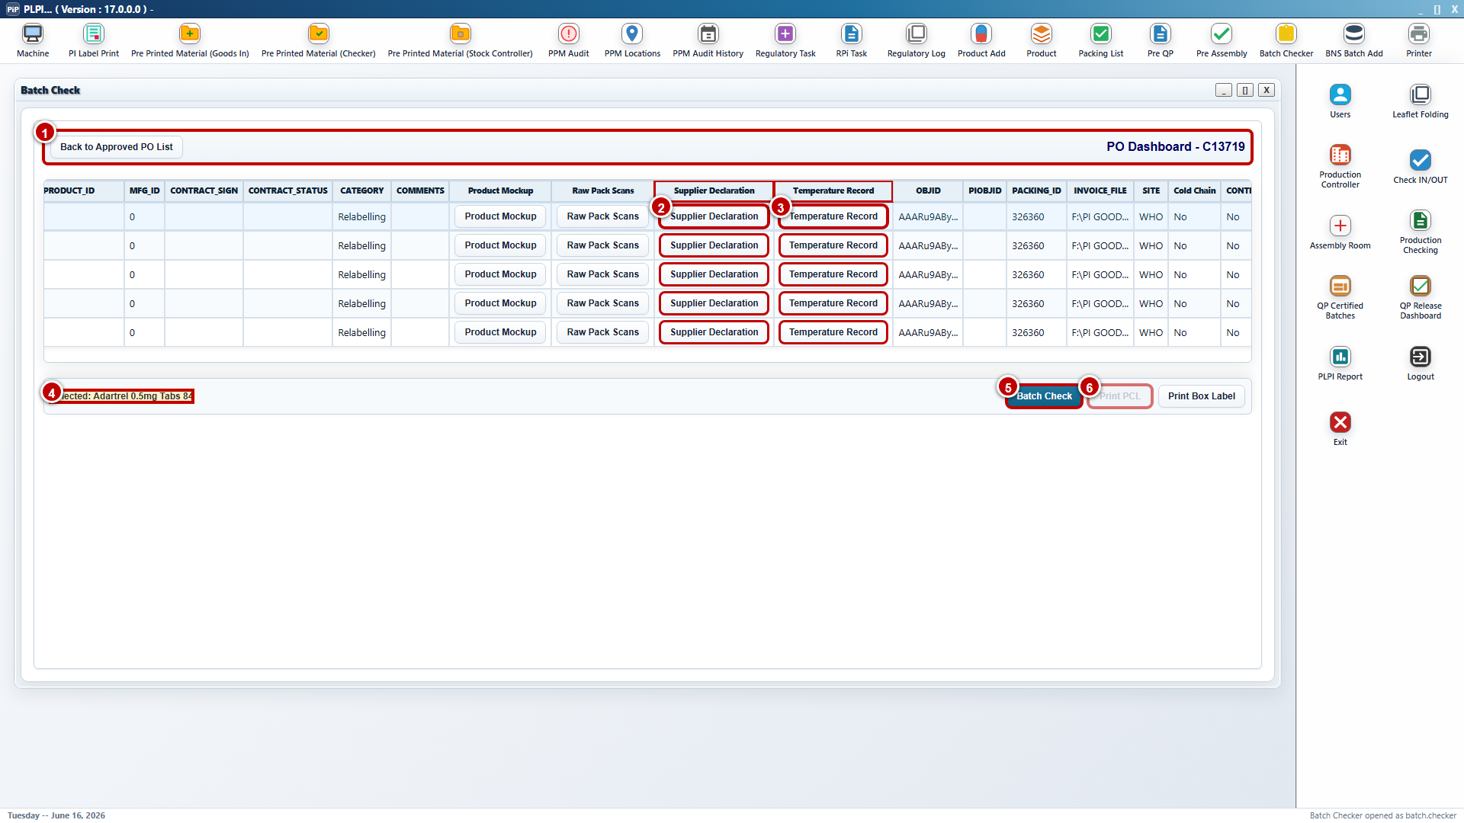
Figure 13 - Batch Checker evidence and action controls
Callout 1 - Approved PO dashboard. The existing Batch Checker search and list workspace displays the selected PO only after RPi approval, approved-pack processing and the external stock-control acceptance are reflected in PLPI. Existing search and list fields remain unchanged.
Callout 2 - Supplier Declaration evidence. This new line-level link opens the approved Supplier Declaration associated with the selected PO and product line. It provides direct evidence access without copying Packing List fields into the Batch Checker module.
Callout 3 - Temperature Record evidence. This new line-level link opens the applicable approved temperature record. When the record is mandatory but unavailable, PLPI prevents completion and directs the user to the missing evidence condition.
Callout 4 - Selected product line. The action strip identifies the currently selected product line. Batch Check, evidence viewing and Print PCL apply only to this line, preventing an action from being posted against another row in the PO.
Callout 5 - Batch Check. The updated action opens Product Verification for the selected line. PLPI does not mark the line as checked merely because the pop-up was opened; the user must complete every mandatory verification and select Verify.
Callout 6 - Print PCL. This action remains disabled until successful Product Verification is stored against the selected line. When enabled, it opens the Product Check Log preview populated with the verified values and completed checks.
Existing fields: The existing Batch Checker search fields, list fields and existing actions remain unchanged.
Eligibility: The list displays RP/RPi-approved packs only after the external stock-control update is reflected in PLPI.
New evidence links: Supplier Declaration and Temperature Record provide direct access to the applicable approved documents for the selected product line.
Updated actions: Batch Check opens Product Verification for the selected line. Print PCL remains unavailable until Product Verification has been completed successfully.
Entry condition: RP/RPi approval and PDF/email processing are complete and the external stock-control acceptance has been reflected in PLPI.
Step 1 - Open Batch Checker. The authorised Batch Checker opens the existing module and uses the existing search and filter controls.
Step 2 - Locate the eligible PO. PLPI lists only records that satisfy the preceding approval and stock-control gates.
Step 3 - Select a product line. The user selects the required product and batch line. Actions apply only to that selected line.
Step 4 - Review Supplier Declaration. The new evidence link opens the approved supplier declaration associated with the PO where applicable.
Step 5 - Review Temperature Record. The new evidence link opens the applicable temperature evidence. An unavailable mandatory record prevents completion.
Step 6 - Start Batch Check. The user selects Batch Check and PLPI opens Product Verification for the selected line.
Step 7 - Control Print PCL. Print PCL remains disabled for the line until successful Product Verification is recorded.
Existing-field boundary: No existing Packing List fields are added to the Batch Checker design, and no existing Batch Checker list fields are described as new.
Exit condition: The selected line has the required evidence available and is ready for Product Verification.
URS traceability: URS 4.3.1, 4.3.2, 4.3.8 and 4.3.9. FS traceability: FS 3.4.

3.5 Product Verification Pop-up
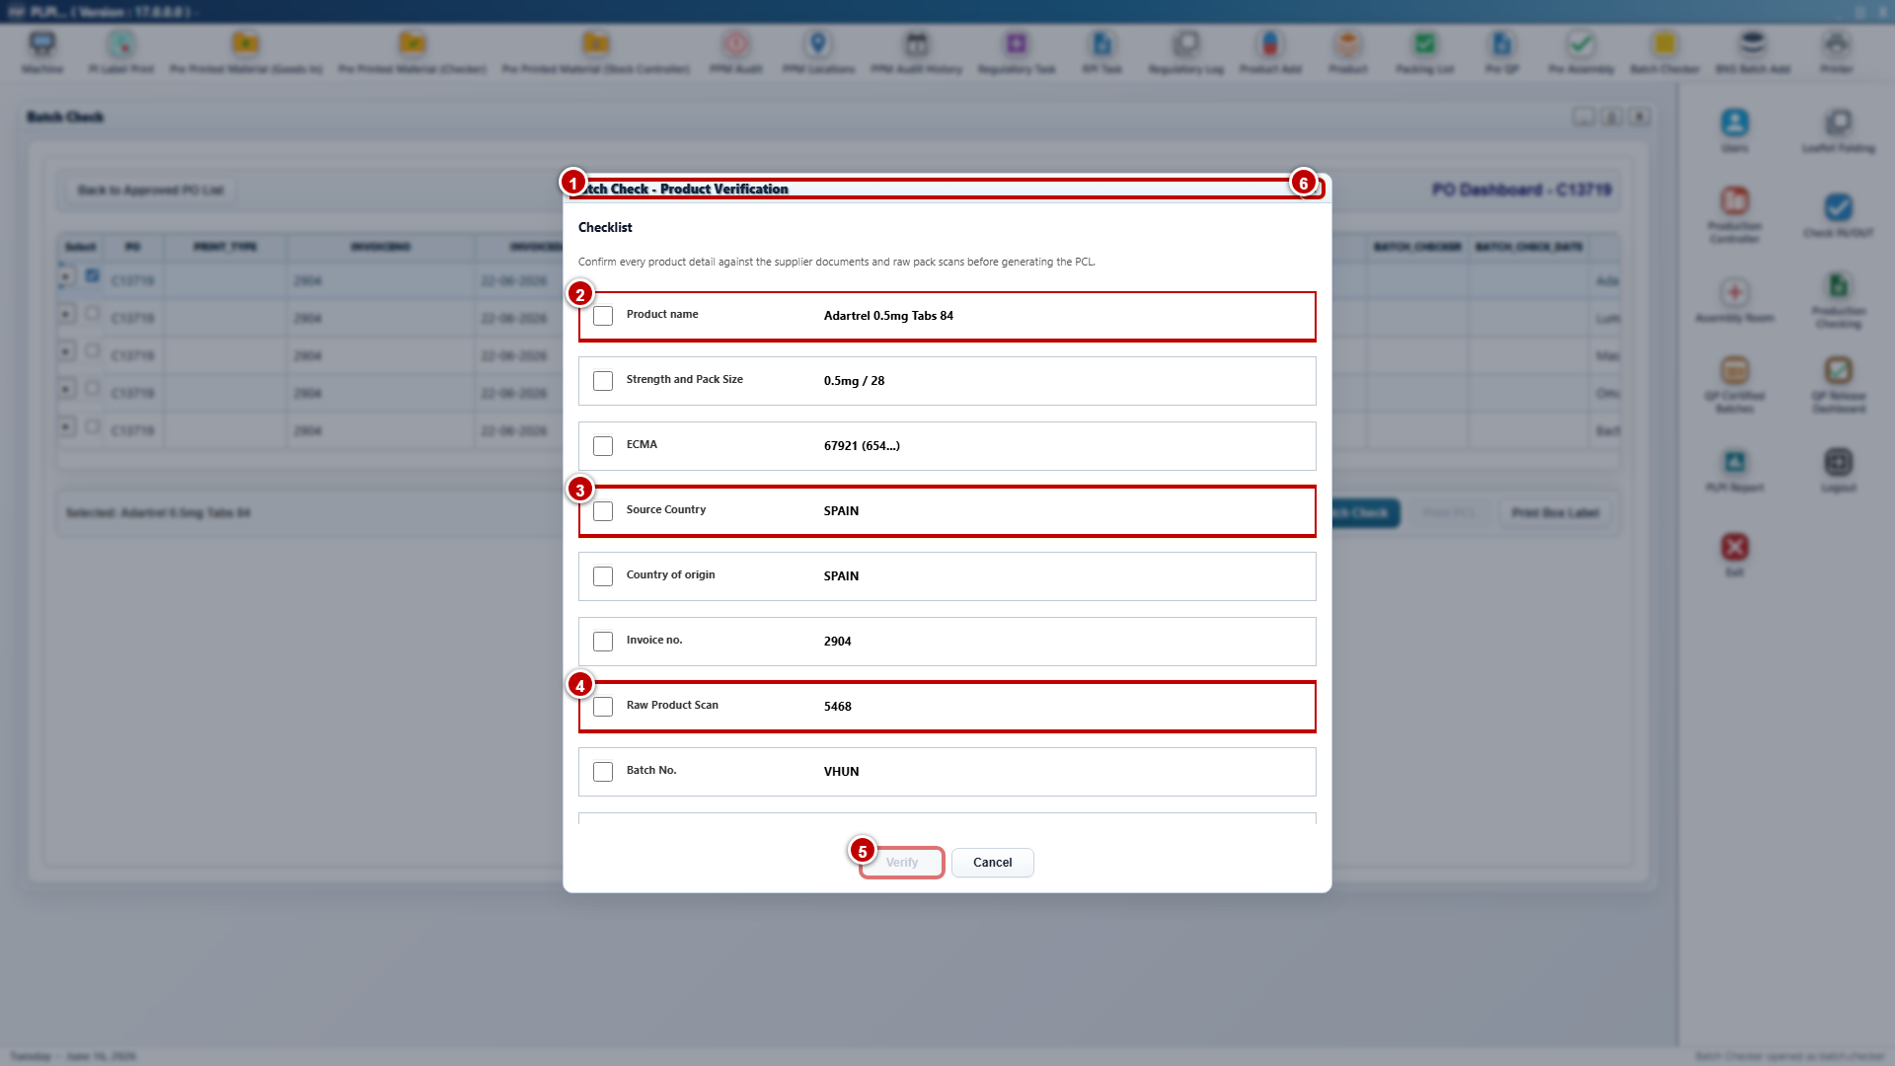
Figure 14 - Product Verification pop-up: identity and source checks
Callout 1 - Product Verification window. PLPI opens the modal from Batch Check and binds it to the selected PO and product line. The user remains in the Batch Checker context and cannot apply the verification to another line while the window is open.
Callout 2 - Product identity checks. The first controlled checks cover Product Name, Strength and Pack Size, and ECMA. The displayed values come from the selected line and are compared with the approved records, supplier documentation and physical or scanned evidence.
Callout 3 - Country and invoice checks. Source Country, Country of Origin and Invoice No. are presented as individual confirmations. A mismatch is not accepted through the check box; the source record must be corrected through the owning process and the line reverified.
Callout 4 - Raw scan and batch commencement. Raw Product Scan starts the physical-evidence group and is followed by Batch No. and MFG Lot No. The user confirms that the scanned or physical pack evidence matches the system-held line data.
Callout 5 - Verify gate. Verify remains disabled while any mandatory check in either the upper or lower part of the modal is incomplete. On successful selection, PLPI records Batch Checker identity, role and date/time and marks the exact line as verified.
Callout 6 - Cancel or close. Cancel and the close control exit without creating a verification record, without changing the line status and without enabling Print PCL.
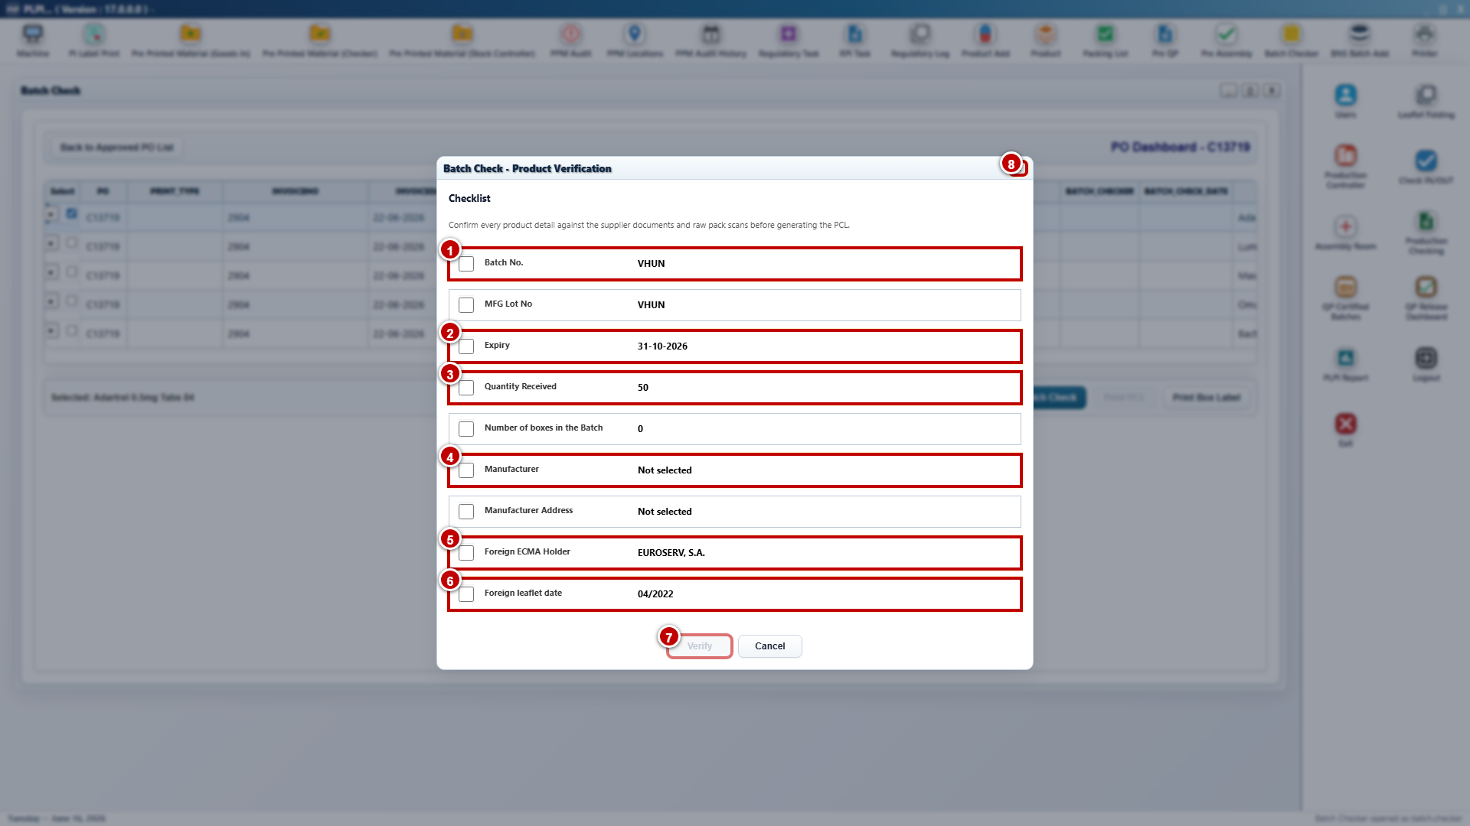
Figure 15 - Product Verification pop-up: batch, quantity and manufacturer checks
Callout 1 - Batch and MFG lot. Batch No. and MFG Lot No. are checked against the physical pack, scan evidence and approved system record. The controls remain separate so a matching batch number cannot conceal an incorrect manufacturing lot.
Callout 2 - Expiry. The Batch Checker confirms the expiry value for the selected line against the pack and supporting evidence. Any discrepancy requires correction and a new controlled verification.
Callout 3 - Quantity and boxes. Quantity Received and Number of Boxes are confirmed against the Goods-In and Packing List records. The values support reconciliation of the received stock before the PCL is generated.
Callout 4 - Manufacturer details. Manufacturer and Manufacturer Address are verified as separate values. A missing or unselected manufacturer keeps the line incomplete and must be resolved before Verify can become available.
Callout 5 - Foreign ECMA Holder. The user confirms the displayed foreign ECMA holder against the approved product and supplier documentation for the selected line.
Callout 6 - Foreign Leaflet Date. The applicable foreign leaflet date is checked against the controlled leaflet or approved source record and is retained in the verified data used by the PCL preview.
Callout 7 - Final Verify. The action becomes available only when every required check across both views is selected. Successful verification updates the line status and writes the authenticated audit entry once.
Callout 8 - Final Cancel. Cancel closes the modal without partial completion. Checked boxes that were not submitted do not constitute an approved Batch Check record.
Displayed checks: The pop-up presents Product Name, Strength / Pack Size, ECMA, Source Country, Country of Origin, Invoice No., Raw Product Scan, Batch No., MFG Lot No., Expiry, Quantity Received, Number of Boxes, Manufacturer, Manufacturer Address, Foreign ECMA Holder and Foreign Leaflet Date.
Verification gate: Verify is enabled only after all required checks are completed. Successful verification records the Batch Checker user, role and date/time against the product line.
Cancel: Cancel closes the pop-up without creating a verification record or changing the line status.
Detailed verification sequence: The Batch Checker completes the pop-up as follows.
Step 1 - Open the selected line. PLPI loads Product Verification for the selected Batch Checker line and prevents the result from being applied to a different line.
Step 2 - Review product identity. The user verifies Product Name, Strength / Pack Size and ECMA against approved records and physical evidence.
Step 3 - Review country and invoice details. The user verifies Source Country, Country of Origin and Invoice No.
Step 4 - Review scan and batch details. The user verifies Raw Product Scan, Batch No., MFG Lot No. and Expiry.
Step 5 - Review received quantities. The user verifies Quantity Received and Number of Boxes against Goods-In and Packing List records.
Step 6 - Review manufacturer and leaflet details. The user verifies Manufacturer, Manufacturer Address, Foreign ECMA Holder and Foreign Leaflet Date.
Step 7 - Complete verification. After all mandatory checks are selected, Verify becomes available. PLPI records user, role and date/time and marks the line as batch checked.
Validation and exception handling: A missing mandatory check keeps Verify disabled. Cancel creates no verification record. A corrected source record requires the applicable line to be verified again.
Exit condition: Successful Product Verification is stored against the selected line and Print PCL becomes available.
URS traceability: URS 4.3.3, 4.3.7 and 4.3.9. FS traceability: FS 3.5.

3.6 Print PCL Preview and Verification
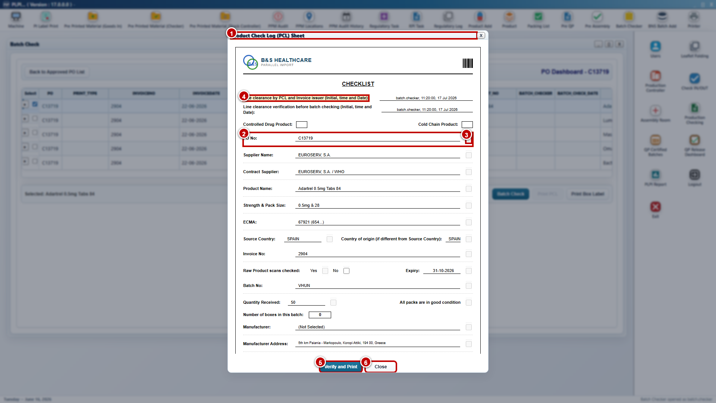
Figure 16 - Product Check Log preview and print control
Callout 1 - Product Check Log preview. The window is a controlled preview generated for the selected verified line. It displays the PCL title and one-page context before the user performs the final clearance and print action.
Callout 2 - Verified detail line. The preview populates PO, supplier, product, strength and pack size, ECMA, country, invoice, scan, batch, expiry, quantity, boxes and manufacturer information from the selected verified record rather than asking the user to retype it.
Callout 3 - Completion checkboxes. Each displayed PCL item has a review confirmation where required. The user confirms that the populated value and associated check are correct; incomplete mandatory confirmation prevents final printing.
Callout 4 - Line-clearance audit evidence. The preview displays line-clearance evidence before Batch Check, including the recorded user and date/time. This establishes that the applicable operational clearance preceded the final PCL action.
Callout 5 - Verify and Print. The action remains disabled until Product Verification, mandatory preview checks and line clearance are complete. Successful printing records print status, authenticated user, role and date/time and releases the completed PCL to authorised downstream users.
Callout 6 - Close. Close exits the preview without recording a successful print. The line remains incomplete for the PCL stage and downstream gating remains in place.
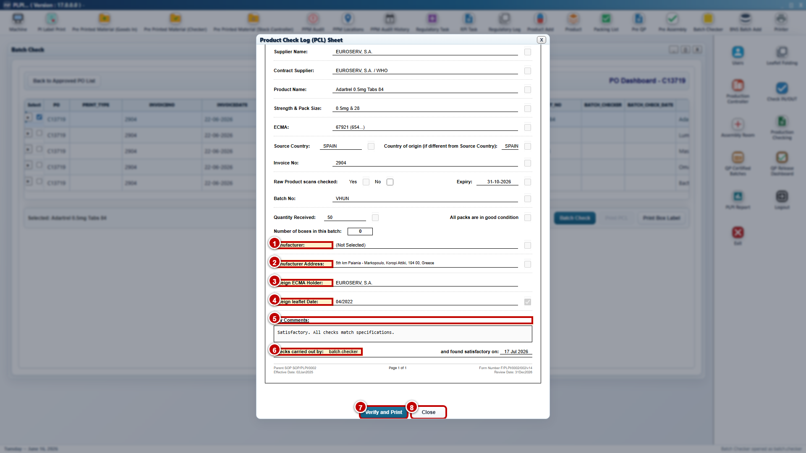
Figure 17 - Product Check Log lower details, audit and print controls
Callout 1 - Manufacturer. The PCL displays the manufacturer value carried from the verified Product Verification result. The value is reviewable in the preview but is not edited as uncontrolled free text at print time.
Callout 2 - Manufacturer address. The verified manufacturer address is displayed separately so the user can confirm both organisation and location before the PCL is finalised.
Callout 3 - Foreign ECMA holder. The foreign ECMA holder is populated from the verified line and included in the final PCL record for product and regulatory traceability.
Callout 4 - Foreign leaflet date. The preview displays the verified leaflet date and its completed confirmation, ensuring the final printed record reflects the applicable controlled leaflet information.
Callout 5 - PCL comments. Comments present the verification conclusion and any applicable supporting context. The content becomes part of the printed PCL and must remain associated with the selected line.
Callout 6 - Checks carried out by. PLPI displays the Batch Checker identity and completion date drawn from the successful Product Verification audit record. These fields are system populated and provide the signatory trace for the printed PCL.
Callout 7 - Final Verify and Print. Selecting this control executes the final validated print action. A print failure does not create successful status; a permitted reprint retains the original verification history and records the additional event.
Callout 8 - Final Close. Closing the lower preview creates no print event and does not satisfy the downstream completion gate.
PCL preview: Print PCL opens a preview populated with the successfully verified product details and completed checks.
Line clearance: The preview requires the applicable area, product and documentation clearance confirmations before final sign-off.
Verify and Print: The action is enabled only when Batch Check verification and mandatory line clearance are complete. PLPI records print status, user, role and date/time.
Close and downstream gate: Close exits without printing. Downstream activity remains blocked until the applicable Batch Checker review; line clearance and PCL requirements are complete.
Detailed preview and print sequence: The Product Check Log is finalised as follows.
Step 1 - Select Print PCL. PLPI confirms that the selected line has a successful Batch Check record before opening the preview.
Step 2 - Populate the preview. The preview is populated from verified product, batch, quantity, manufacturer and document-check values.
Step 3 - Display completed checks. The preview shows the checks completed in Product Verification for final review.
Step 4 - Complete line clearance. The user confirms the applicable area, product and documentation clearance items.
Step 5 - Review the final PCL. The user confirms that displayed details and checks relate to the selected PO and line.
Step 6 - Verify and print. PLPI enables Verify and Print only when all mandatory preview and clearance checks are complete.
Step 7 - Record the print event. After successful printing, PLPI records print status, user, role and date/time.
Step 8 - Complete the stage. The PCL becomes available to authorised downstream users and the Phase 1 completion gate is satisfied for the line.
Validation and exception handling: Close exits without printing. A print failure cannot record successful status. Reprinting retains the original verification history and records the additional print event where supported.
Exit condition: The line has completed Batch Check, line clearance and printed PCL; downstream activity starts only when all applicable lines satisfy the controls.
URS traceability: URS 4.3.4 - 4.3.8. FS traceability: FS 3.6.

3.7 Goods-In Summary
The Goods-In Summary is a new read-only module for authorised Business, QA, Operations and IT users. It presents the current Goods-In and RPi workflow state without exposing operational amendment controls.
Search and result list: PO Number Search filters individual and merged records. Each result displays PO Number(s), Supplier, Current Stage and Last Updated. A merged result retains all related PO numbers.
View Summary: The action opens the selected record and displays the WSC initiation, tablet completion, Team Lead decision, Packing List activities, RPi Pack Creation, RPi decision and PDF/email processing status applicable to that PO or merged set.
Action History: The read-only log displays stage, action, authenticated user and date/time in recorded sequence. Correction, rejection, unmerge and re-submission events remain visible and are not replaced by the latest status.
View Summary PDF: The preview is generated from recorded workflow events and shows the applicable individual or merged PO relationship. It cannot be used to change the source operational record.
Detailed summary sequence:
Step 1 - The authorised user searches by PO number and selects the applicable individual or merged result.
Step 2 - PLPI displays the current stage and latest update from the controlled workflow record.
Step 3 - The user opens View Summary to review the retained stage history and document/approval outcomes.
Step 4 - The user opens View Summary PDF where a printable read-only representation is required. No summary action changes workflow status.
URS traceability: URS 4.4.1. FS traceability: FS 3.7.

3.8 Workflow Status, Corrections and Audit Behaviour
Status control: PLPI shows the current PO, merged-set and line status in the relevant module. A status changes only after the applicable validation and authenticated action succeeds.
Step 1 - PO initiated. Add Packing List has created the RPi Pack Creation queue and linked available source files.
Step 2 - Checklist pending or in progress. WSC has generated the checklist and Goods-In or Lead Approval activity remains incomplete.
Step 3 - Checklist approved or QA required. The Team Lead Yes decision has locked and filed the checklist, or a No decision has quarantined the stock and routed it to QA.
Step 4 - Packing List pending or complete. Verify & Print, LOG, line clearance and generation are evaluated for each PO.
Step 5 - RPi pack in progress. The individual or automatically merged pack is progressively populated and missing documents are being completed.
Step 6 - Ready for RPi Review. The complete pack has been submitted from RPi Pack Creation.
Step 7 - Returned for correction. RPi has rejected the pack with comments or an unmerge/correction requires Goods-In action.
Step 8 - RPi Approved. Document review, checklist and electronic sign-off are complete.
Step 9 - PDF and email processed. The combined pack has been generated and its email outcome recorded.
Step 10 - Ready for Batch Check. External stock-control acceptance has been reflected and the approved PO is visible to Batch Checker.
Step 11 - Batch Check verified and PCL printed. Product Verification, line clearance and controlled PCL printing are complete for the applicable line.
Correction control: A correction returns the record to the owning stage. Affected approvals, document views or generated outputs must be repeated through the controlled workflow.
Audit content: Each controlled event retains the PO or merged-set reference, affected line or document where applicable, previous and new status, authenticated user, role, date/time, decision and comments or reason.

4. Additional Non-Functional Requirements

4.1 Audit Trail
PLPI shall retain traceable records for WSC PO initiation and source-file linkage; delivery details; driver and receiver signatures; the three Goods-In inspection responses; Goods-In submission; Team Lead Information Confirmed decision, comments, signature and final confirmation; completed checklist PDF; line clearance; automatic single-PO or merged-PO linkage; shared and PO-specific document status; unmerge; review; correction; approval; PDF generation; email dispatch; Batch Check verification; PCL printing; and summary access. Records shall include the applicable PO, merged set, line or document, user, role, action, previous and new status, comments or reason, and date/time where applicable.

4.2 Availability
The new workflow shall operate within the established PLPI availability and planned maintenance arrangements. Saved records shall remain available to authorised users after service restoration.

4.3 Capacity Limits
The design shall support the expected operational volume of individual and merged PO sets, product lines, checklist records, signatures, shared documents, PO-specific documents and concurrent authorised tablet or desktop users. Shared documents shall be stored once for a merged set where applicable. Record locking shall prevent conflicting updates to the same controlled task.

4.4 Performance
Search, document status, checklist validation, preview and sign-off actions shall respond within acceptable operational time under normal PLPI load. Large PDF generation and email processing shall show a clear in-progress or completion status.

4.5 Recoverability
Goods-In and Lead Approval drafts, final checklist data, signatures, PO and merged-set relationships, linked source files, uploaded files and generated records shall be included in the existing database and file backup and recovery controls. A draft is not the final controlled record. A failed PDF or email action shall be recoverable without duplicating approval records.

4.6 Security Requirements
Access shall use existing PLPI authentication and role permissions. WSC India, Goods-In, Goods-In Team Lead, RP/RPi and Batch Checker actions shall be available only to authorised roles. Team Lead approval shall be separated from Goods-In data capture. Internal electronic sign-off shall use authenticated identity; driver, receiver and Team Lead signatures shall be retained with the completed receiving record. The Goods-In Summary shall remain read-only.

4.7 Error Handling
The system shall display clear validation or processing messages for missing mandatory delivery data, unanswered inspection checks, missing signatures, incomplete Team Lead approval, missing PO or document relationships, incomplete line clearance, missing shared or PO-specific documents, unmerge without a reason, failed generation, failed email dispatch and unavailable records. Errors shall not advance workflow status or create an incomplete controlled record.

4.8 Usability
The Goods Receiving Checklist and signature controls shall be usable on the approved tablet form factor. Goods-In Team and Lead Approval queues, workflow stepper, three mandatory inspection checks, Information Confirmed decision, final confirmation and disabled actions shall be clear without changing the established PLPI navigation pattern. RPi Pack Creation shall distinguish shared documents from PO-specific documents and identify only files that require upload.

4.9 Accuracy and Validity
WSC-loaded values, PO relationships, mandatory responses, driver and receiver signatures, Team Lead decision and signature, automatic document links, shared-document rules and workflow gates shall be validated before the applicable record is completed. The checklist PDF, generated Packing Lists, combined PDF, summary and PCL shall use the applicable controlled values held in PLPI.

